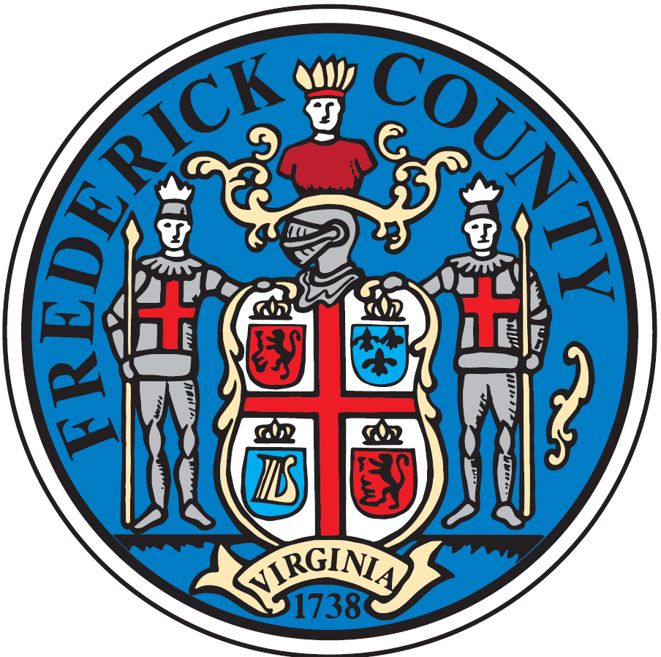

FREDERICK COUNTY LOCAL GOVERNMENT

Employment Opportunities
Salary Level is evaluated on an individual basis, dependent on qualifications and experience.
Northwestern Regional Adult Center
Licensed Practical Nurse | Full-Time | Salary- $36,800 - $58,800
Maintenance Technician | Full-Time | Salary- $32,300 - $51,700
Correctional Officer | Full-Time | Salary- $36,800 - $58,800

Parks and Recreation
Part-Time Park Maintenance | Part-Time | $11.75/Hour
Part-Time Park Ranger | Part-Time | $12.00/Hour

Victim/Witness Program
Office Assistant | Full-Time | Salary-$29,500-$47,100

Frederick County Landfill
Part-Time Laborer | Part-Time | $10.00/Hour

Children’s Services Act
CSA Account Specialist | Full-Time | Salary- $32,300 - $51,700
Frederick County is an Equal Opportunity Employer
To Apply, Visit: www.fcva.us/jobs.
Interested in Volunteering?
JOIN US TODAY!
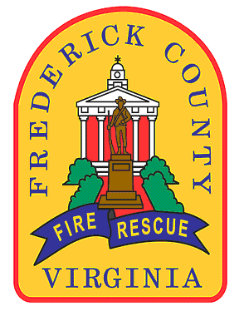
Frederick County Fire & Rescue
WWW.COURAGETOCARE.NET
540.722.8358

Volunteer with Frederick County Fire and Rescue!
Volunteer Opportunities available, for more information visit our Webpage at www.fcva.us.

