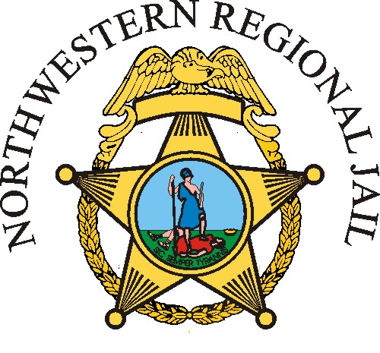  Position Information:  Salary: CO1- $49, 510  CO2- $51,985  CO3- $54,584  Full-Time Employment  Frederick County Employees receive Great Benefits!  Benefits Include: Health, Dental, Vision, Life Insurance, Optional Life and Disability Plans, and enrollment into the Virginia Retirement System!  Opportunities for Advancement are Available!
  Application Process:
  The Adult Detention Center recruitment and selection process supports the County of Frederick Equal Opportunity and Affirmative Action Plans. Applicants must successfully complete the following phases:
  - Submit completed application
  - Criminal History Review
  - Driving record review
  - Pre-screening interview
  - Pre-Employment Physical Agility Test
  - Polygraph examination
  - Background interview and investigation
  - Conditional offer of employment
  - Medical Physical
  - Final approval by Superintendent
  When applying the listing is under Correctional Officer.
  Questions?
  
  Phone: 540-535-3800
  Apply at fcva.us
  
  
  www.facebook.com/NorthwesternRegionalADC
  Northwestern Regional Adult Detention Center
  141 Fort Collier Road
  Winchester, VA 22603
  Correctional Officer
  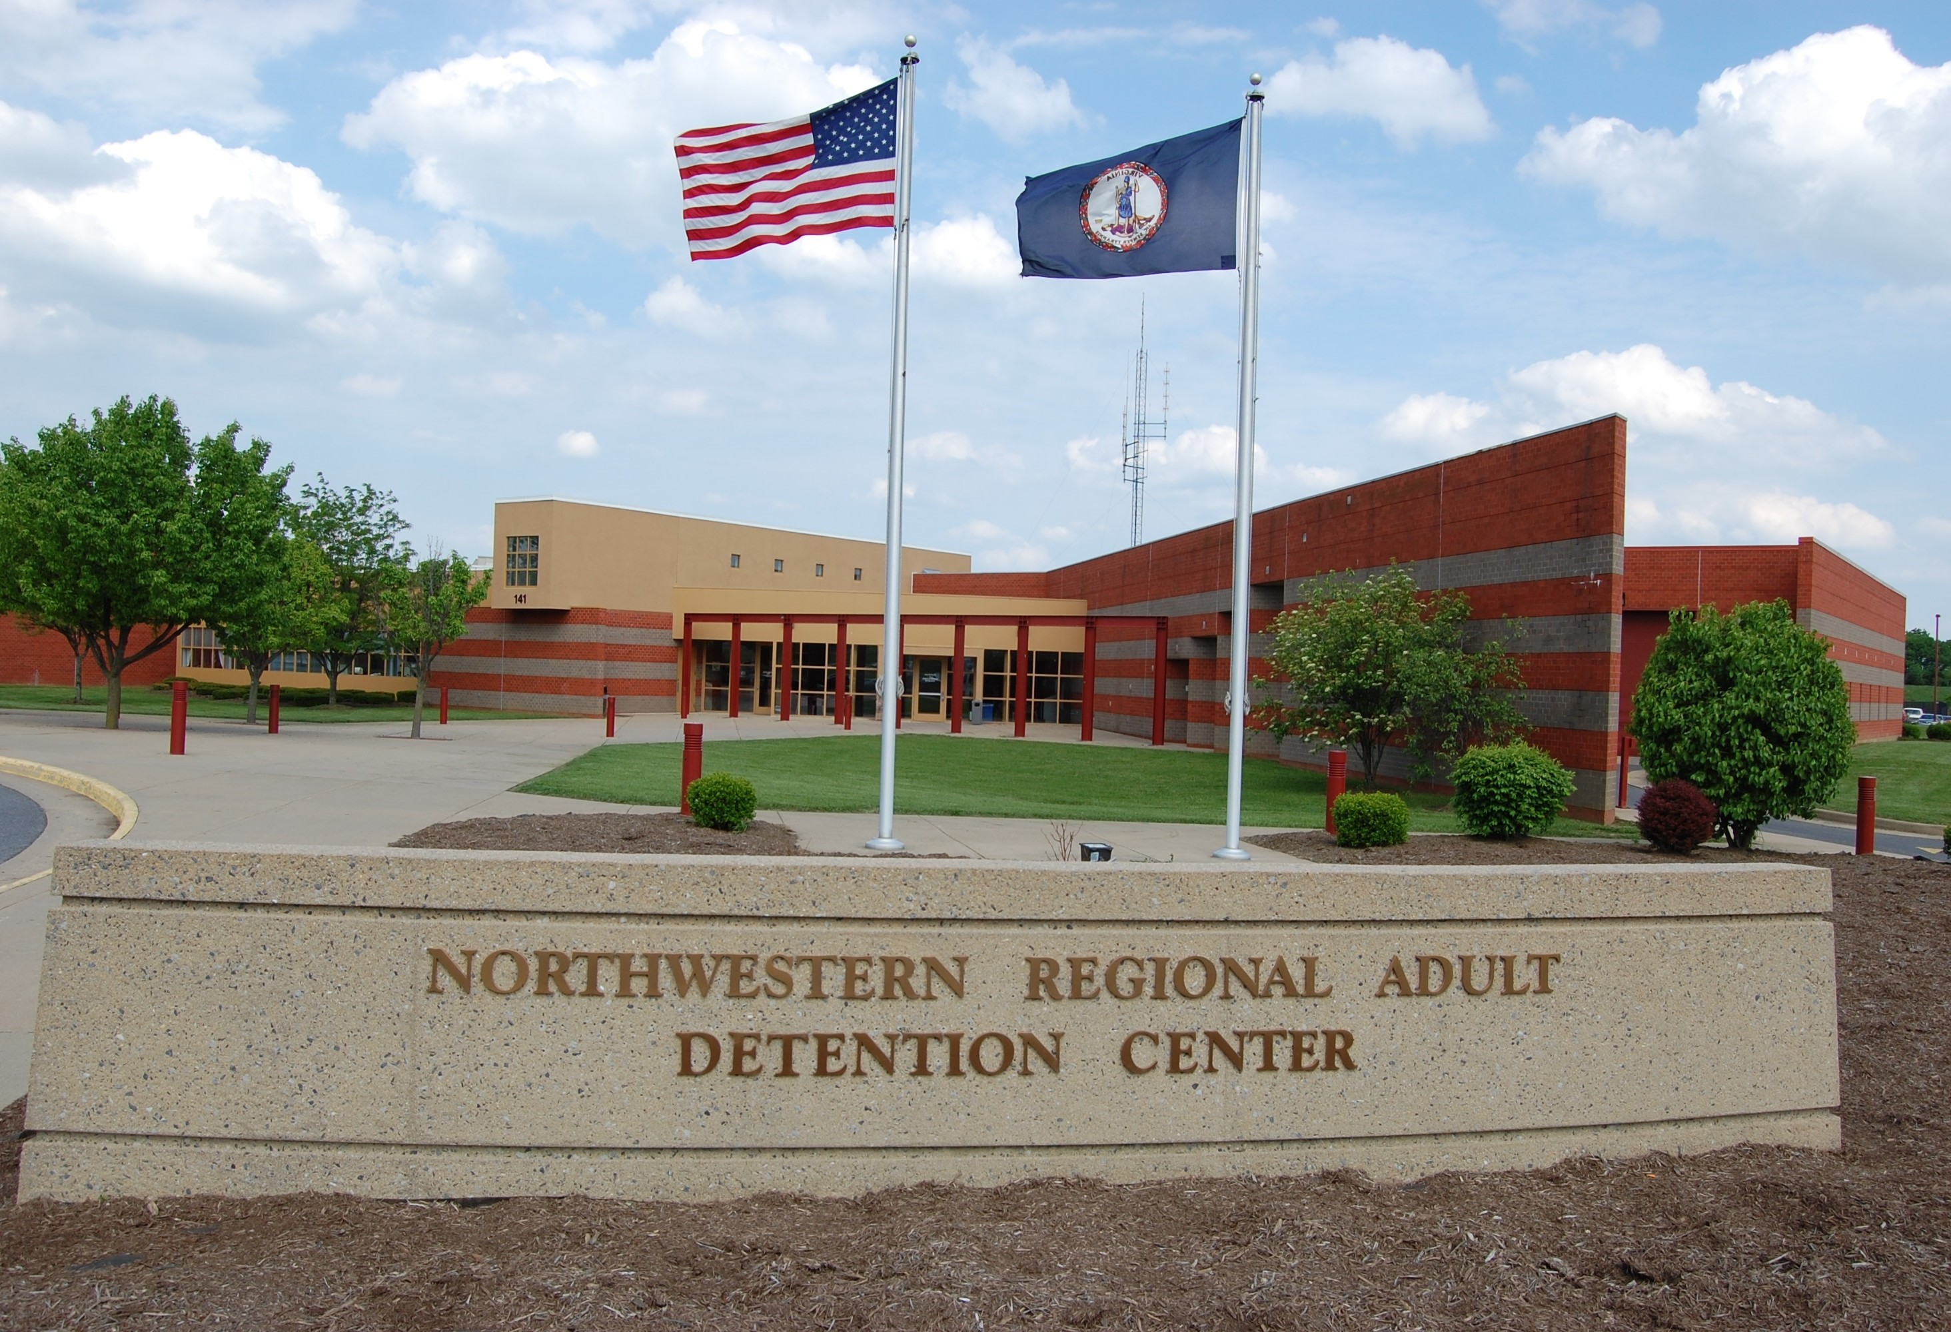
  Northwestern Regional Adult Detention Center
Are you looking to start a career in Law Enforcement?  If yes, then we are a great place to start!  The Northwestern Regional Adult Detention Center is a great opportunity to start your Law Enforcement Career! All Officers who are employed with Northwestern Regional Adult Detention Center are fully certified Jail Officers in the State of Virginia after the completion of the Academy. Jail Officers in the State of Virginia have arresting powers and qualify for Law Enforcement Officer Benefits upon retirement.  Position Description:  This work involves the supervision of criminal and sometimes violent offenders in a barrier-free operational environment. Work is normally performed in accordance with established policy and procedure without constant supervision. However, independent judgment and immediate action is often required to ensure safety and security. | 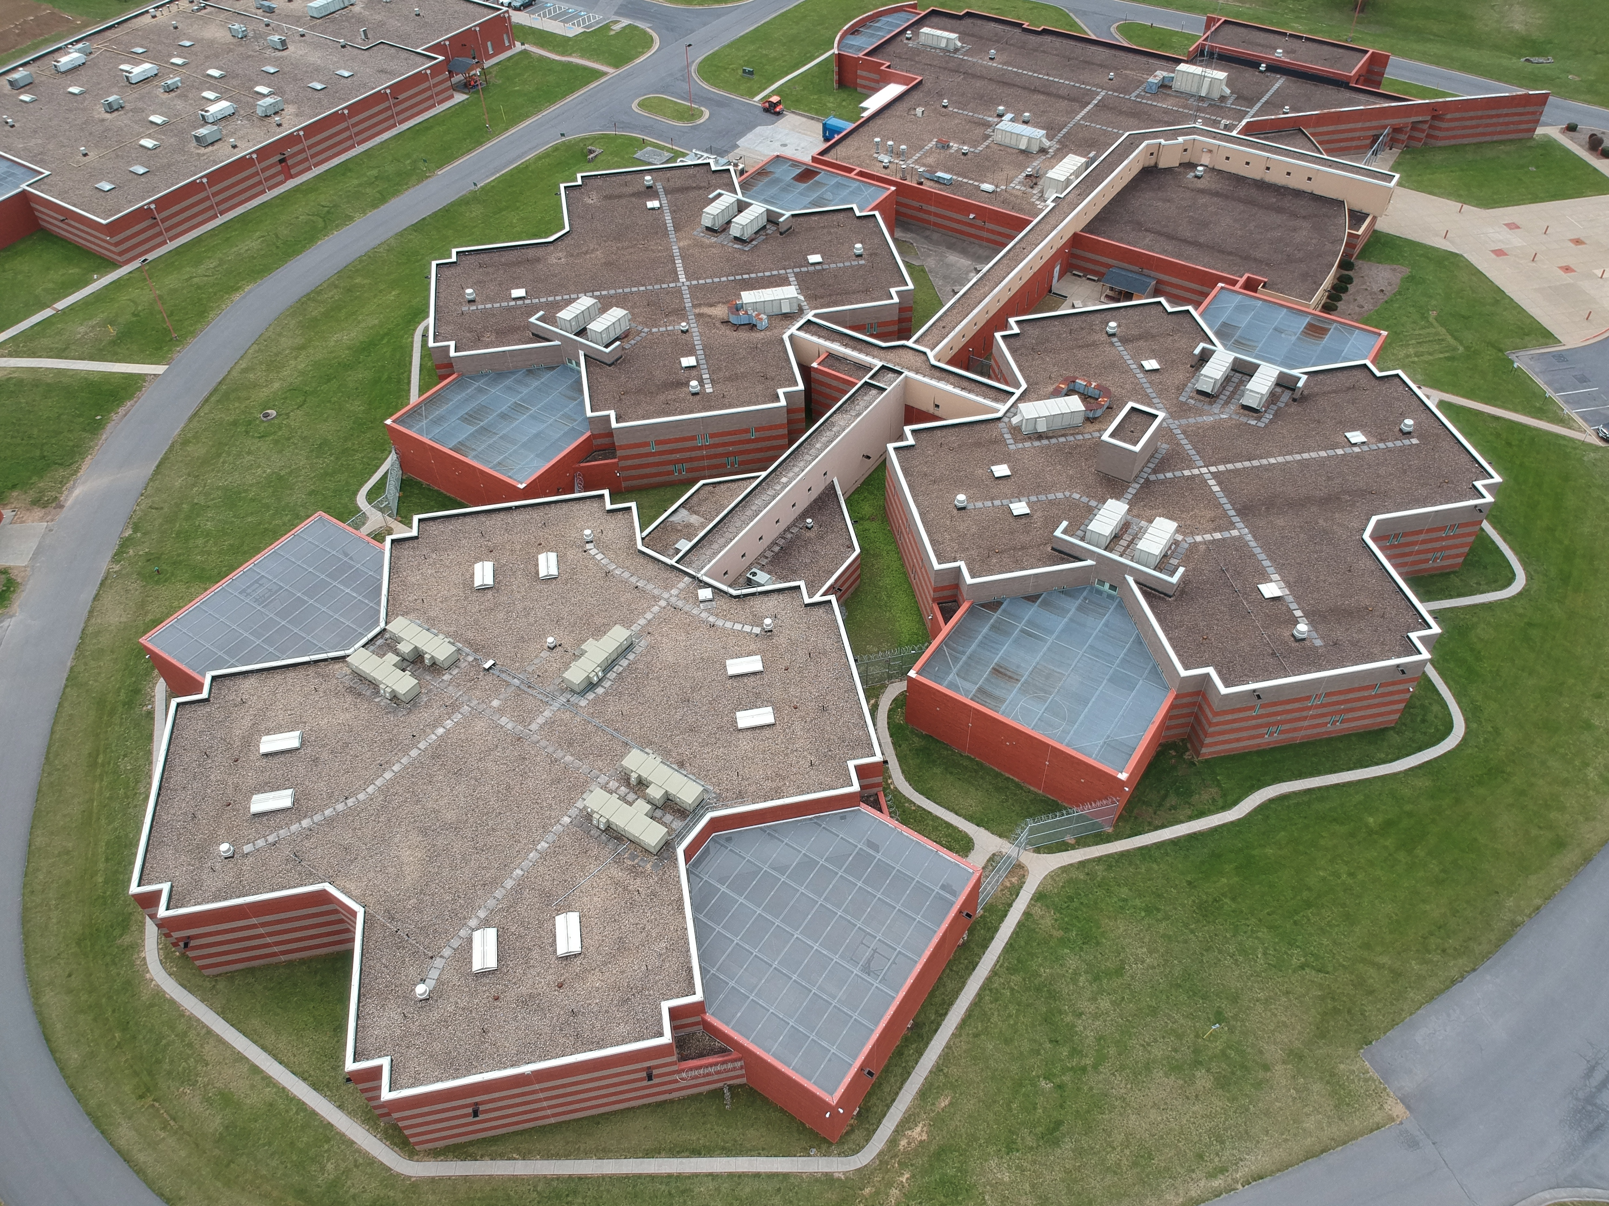  “It definitely has been a challenge, but for the better. Every day you go home, you know you made a difference.” – Officer Romero  Physical Demands:  Communicate effectively both verbally and in writing. Walking, talking, stooping, kneeling, bending, reaching, sitting and gripping for long periods of time. Incumbent may be required on occasion to perform duties that require strenuous movement and lifting. Jail Officers must be capable of running 100 yards and immediately engaging in vigorous physical activity |  | Attributes for this Position:  The incumbent must be capable of communicating verbally and issuing orders in a clear and direct manner  The ability to maintain continuous observation of persons, activities, and surroundings is critical  With training, the incumbent must be capable of applying physical force; rendering first aid and CPR; and qualifying to Virginia Department of Criminal Justice Services (DCJS) standards with a Detention Center-issued pistol and shotgun  With training, the incumbent must be tolerant of short-term, indirect exposure to aerosol and liquid OC  Jail Officers must be capable of running 100 yards and immediately engaging in vigorous physical activity  “I love coming to work! It is something different every day.” – LT. McWilliams

